NEW AIT1000 FROM DIGITAL YACHT
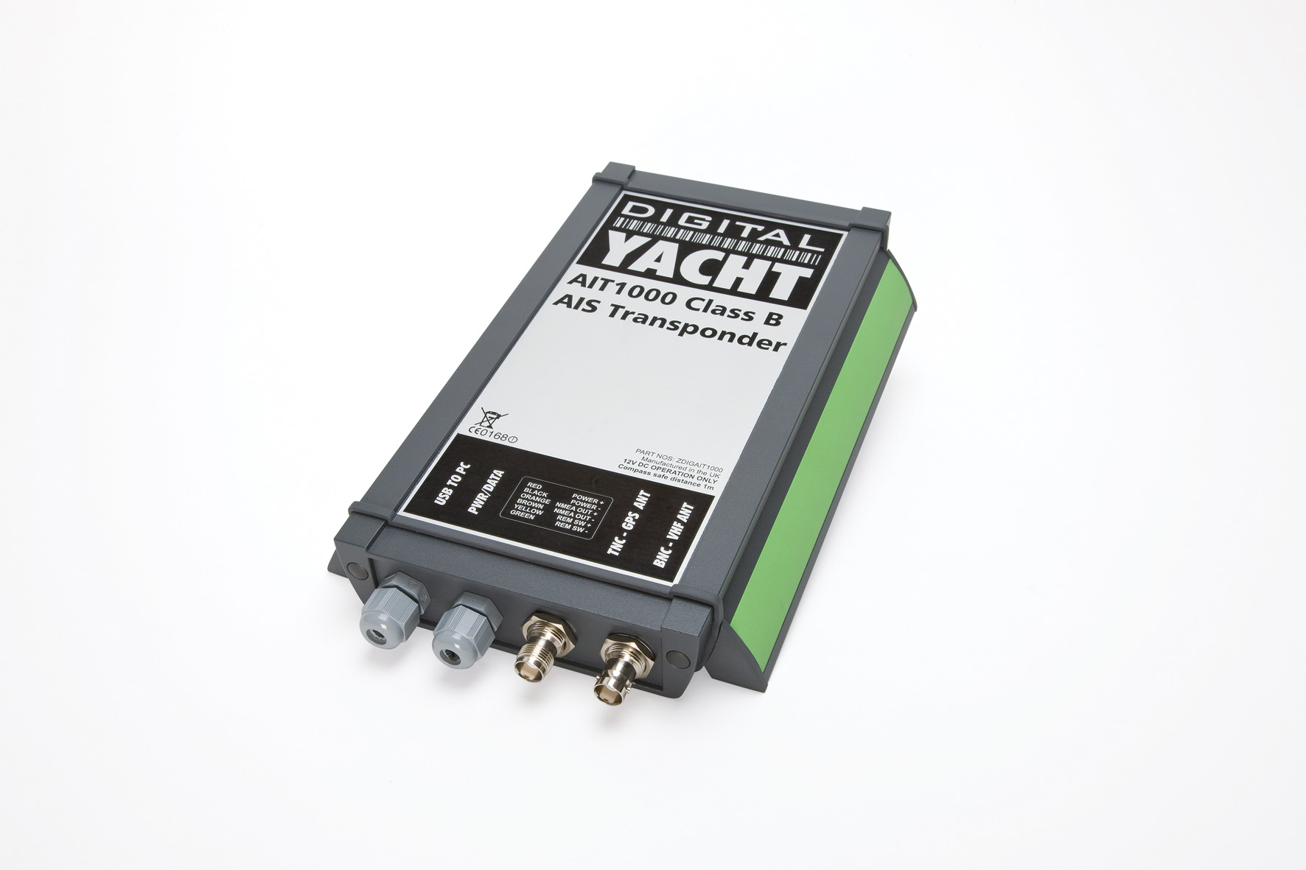
Digital Yacht have introduced their second generation Class B AIS transponder called the AIT1000. It uses the same well proven technology from the previous generation AIT250 product but now comes in a more slimline, compact and waterproof enclosure. It’s also the first transponder to feature a USB interface for PC programming and allowing easy plug ‘n play connection to PC based navigation systems.
There is also a traditional NMEA 0183 output which interfaces with AIS compatible plotters such as Raymarine's C and E Series, Furuno, Navnet, Standard Horizon and Garmin product lines.
As a transponder, the AIT1000 will not only receive AIS data from other surrounding vessels but will also transmit your vessel identity, position and course to other users. For all commercial vessels over 300GRT it is a mandatory requirement to carry an AIS transponder and signals sent from the AIT1000 will be picked up by these devices and navigators automatically warned of any potential collision course. The AIS system offers one of the greatest advances in marine navigation safety for the 21st century.
The AIT1000 comes complete with its own GPS antenna and requires connection to a VHF antenna or a VHF antenna splitter so that the existing VHF antenna on board can be utilised. It also ships with proAIS software which allows programming of the device by a suitably qualified person as well as offering a diagnostics facility and list of all targets received.
The AIT1000 is priced at £499 and is available now.
Further details are available at www.digitalyacht.co.uk

- ENDS -
Notes for editors:
AIS
Class A AIS is now mandatory on all vessels over 300 GRT and any commercial passenger carrying vessel. The system automatically sends a ship's identity, position, course and speed to other vessels equipped with either an AIS transponder or receiver. As such, the system greatly improves both onboard security and safety as well as aiding navigation with a detailed plot of nearby vessels overlaid on to an electronic chart. Class B AIS operates in a similar way but is intended for non-mandatory fitting and is ideal for use on yachts or power boats.
- ENDS -
For further information, please contact:
Digital Yacht Ltd., Digital House, Unit 10 City Business Park, Easton Road, Bristol, BS5 OSP, UK.
Telephone: +44 (0)1179 554474
Email: sales@digitalyacht.co.uk
www.digitalyacht.co.uk

For further press information, please contact:
Tina Mansell at The Mansell Agency
Telephone: +44 (0)1202 701705. Mobile: +44 (0)7973 850012
Email: tina@themansellagency.com
www.themansellagency.com

